Important person

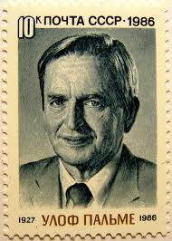

1. Match the Picture with the right letter

1. Dag hammarsköld
2. Ingvar Kamprad
3. August Strindberg
4. Olof Palme

The correct alternative is: d.

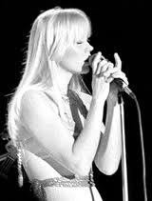

1. Match the picture with the right letter
2. Queen Kristina of Sweden
3. Agneta Fältskog
4. Mona Sahlin
5. Alva Myrdal

The correct alternative is: b.

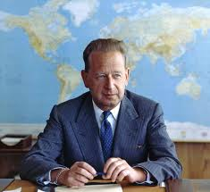

1. Match the picture with the right letter
2. Ingvar Kamprad
3. Olof Palme
4. Dag Hammarsköld
5. Björn Borg

The correct alternative is: c.

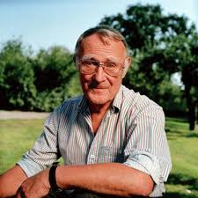

1. Match the picture with the right letter
2. Ingvar Kamprad
3. Olof Palme
4. Dag Hammarsköld
5. Björn Borg

The correct alternative is: a.

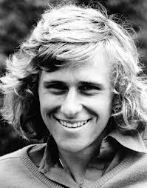

1. Match the picture with the right letter
2. Ingvar Kamprad
3. Olof Palme
4. Dag Hammarsköld
5. Björn Borg

The correct alternative is: d.